

**PSG College of Technology**

Ethical Hacking Package - **AMONG US BOX**

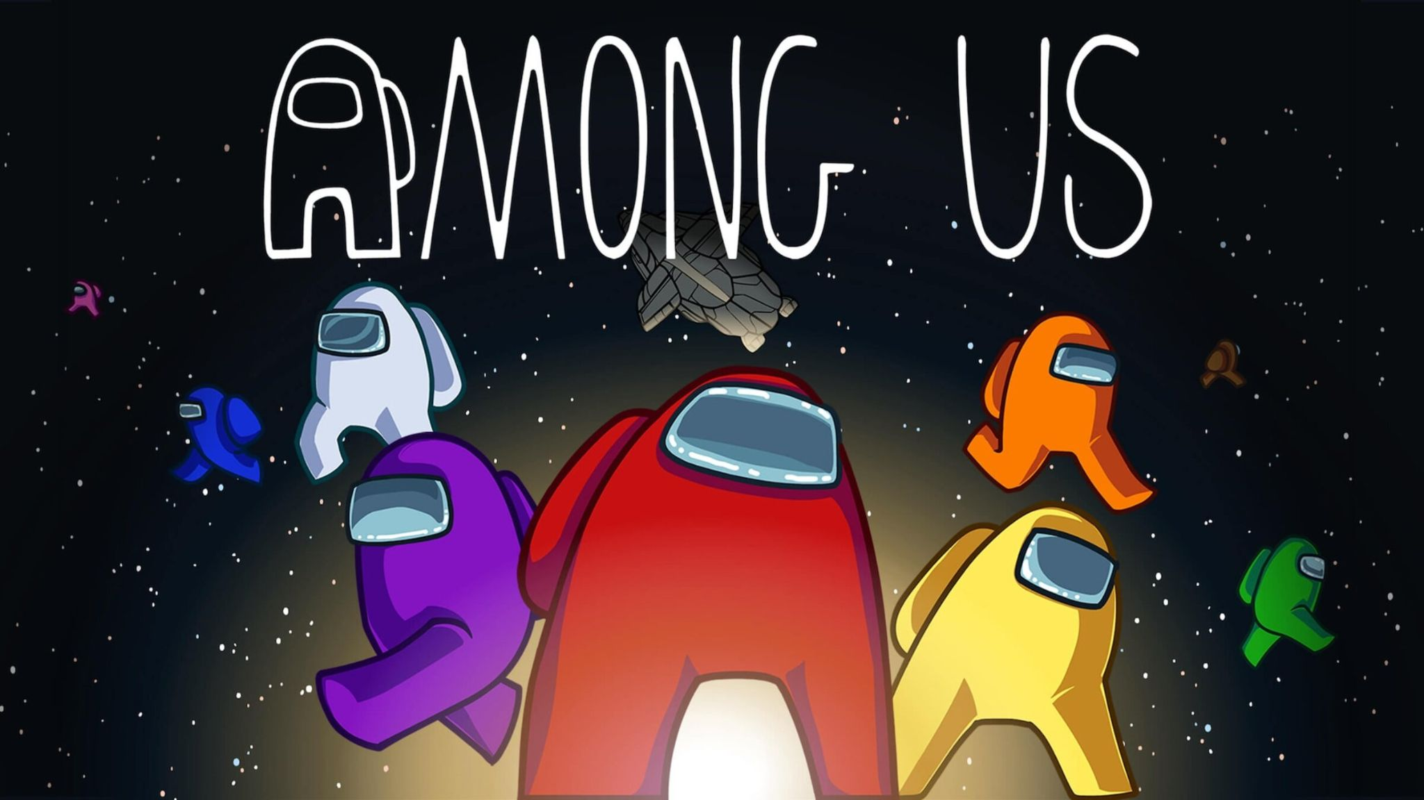

Aparnaa T (21PC04)

Samyukthaa B (21PC28)

Vishnupriya R(21PC39)

**Software used :**

OS - Ubuntu

Version - 20.04

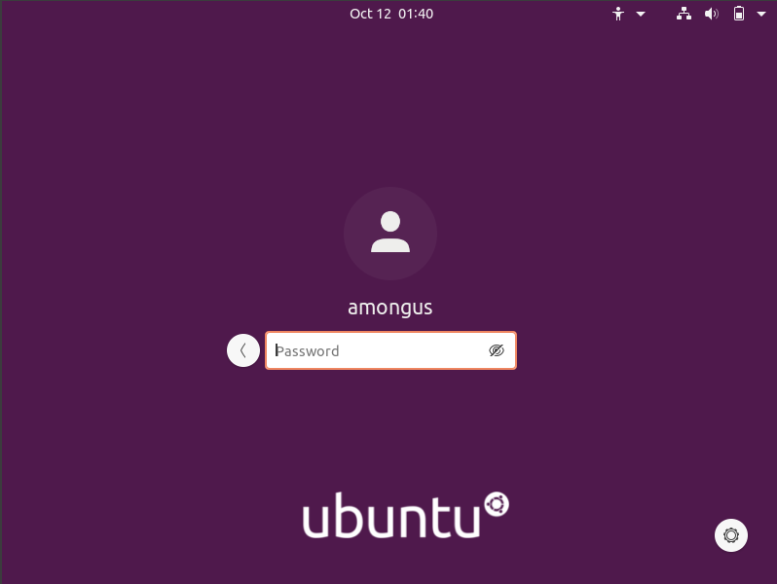

When we open the virtual machine, an account named amongus already exists, but we are unaware of the password.

**Enumeration :**

We create a new NAT network and attach a kali machine and the ubuntu machine to the newly created NAT network, in order to gather information related to the ubuntu machine without logging in.

Run the command **sudo arp-scan –localnet**

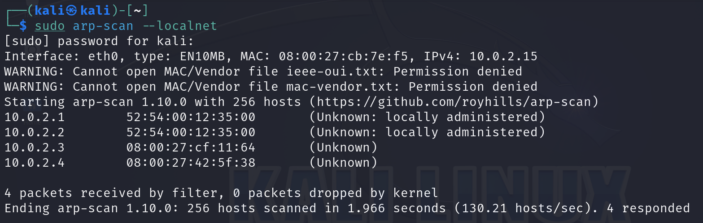

We get 4 IPs.

We run Nmap scan on each IP and try to look for any open ports or anything unusual.

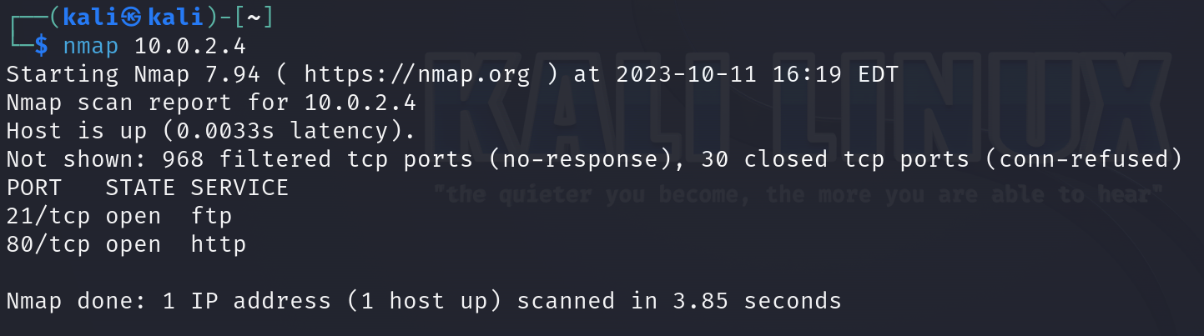

Only the last IP has FTP and HTTP ports open.

So this could be the IP of the target machine.

Using the obtained IP, we can see if <http://10.0.2.4> has anything of use.

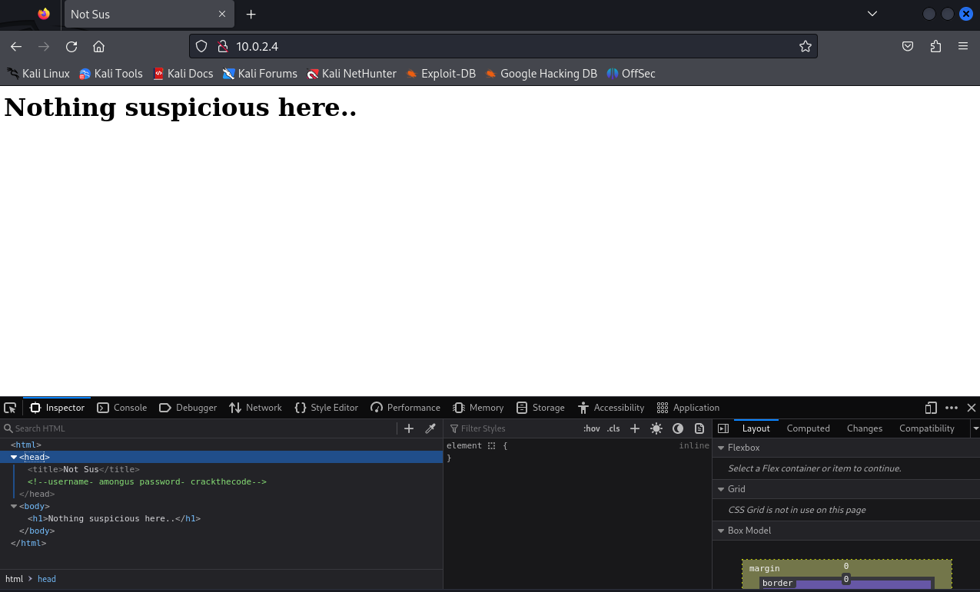

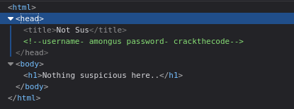

Under inspect, we find the username and password for the target machine.

Username - **amongus**

Password - **crackthecode**

**Exploitation-**

Now, we can use these credentials to see what the ftp port holds.

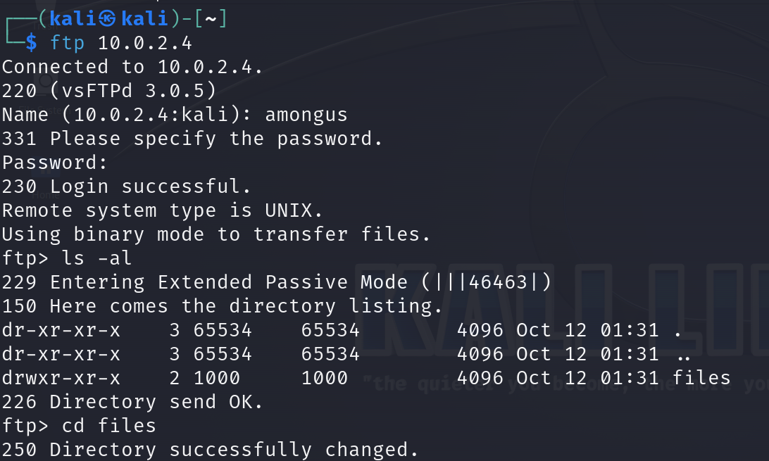

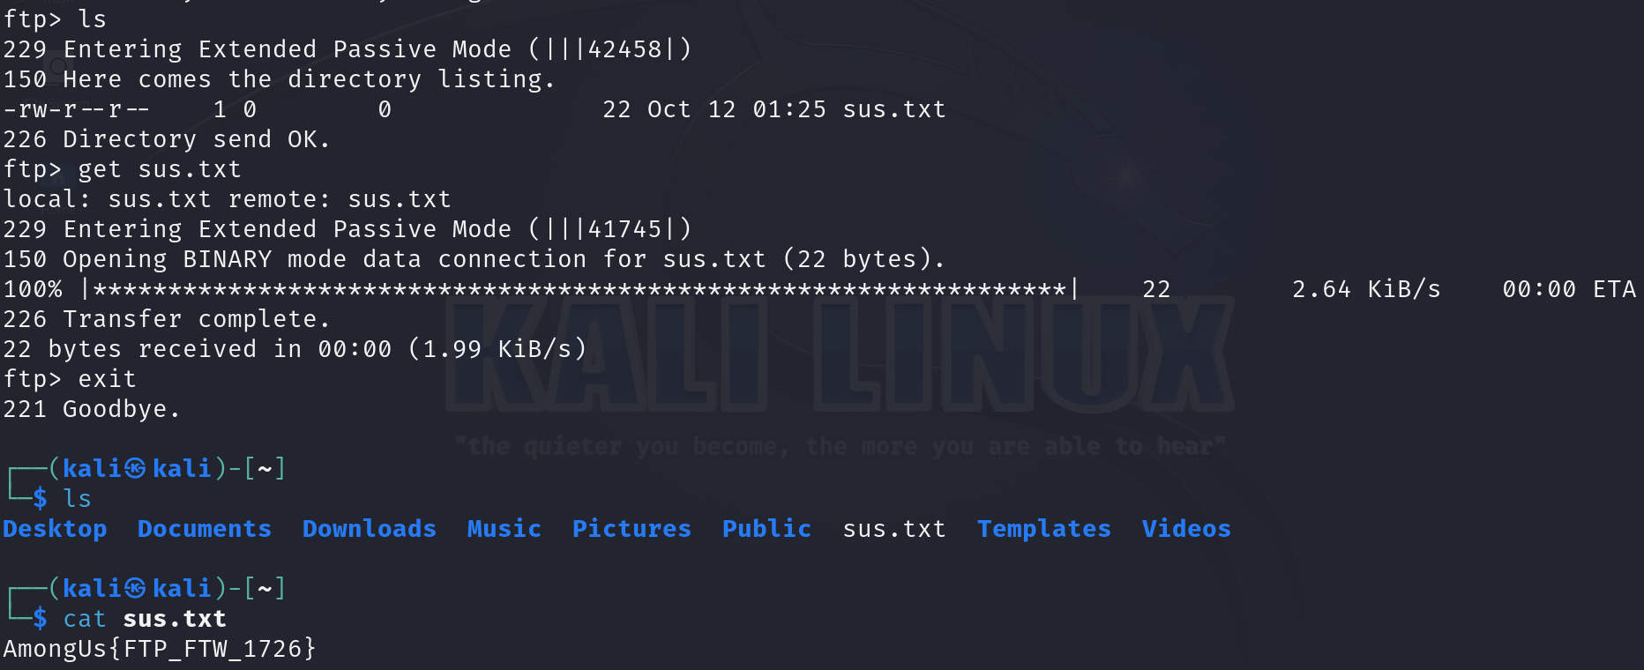

We’ve successfully found our first flag- **AmongUs{FTP_FTW_1726}**

Now, we can log into ubuntu using these credentials too.

Enter into root user using the command : “sudo su root” or “sudo -i”

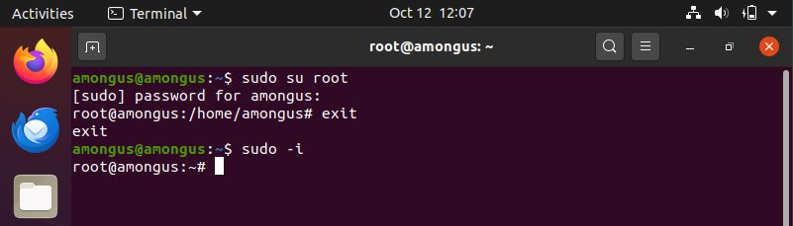

View all the folders present in the root directory. Start with 1Readme.txt



**1Readme.txt** contains the 1st flag.

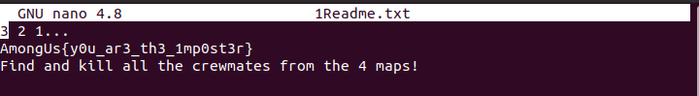



Flag 2 - **AmongUs{y0r_ar3_th3_1mp0st3r}**

Task : Check out all the rooms and complete the tasks.

**Room 1 : Skeld**  
  
  
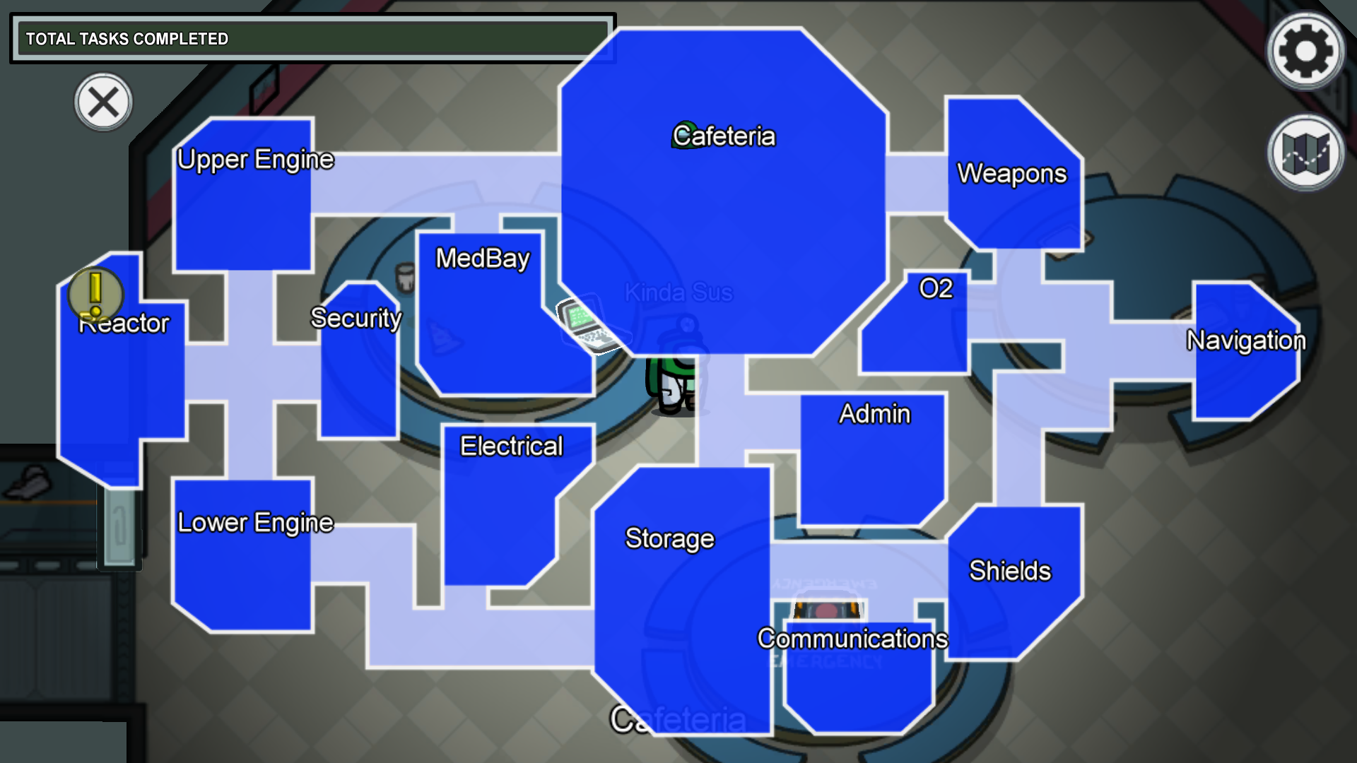

Entering **skeld** following files can be found.

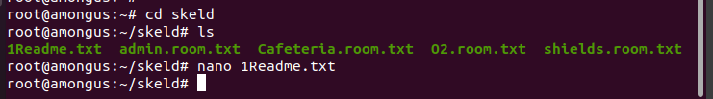

**1Readme.txt** will contain the directions to be followed to find the flags.

Each flags will be connected. Keep following the flags to find the next location.

**1Readme.txt**

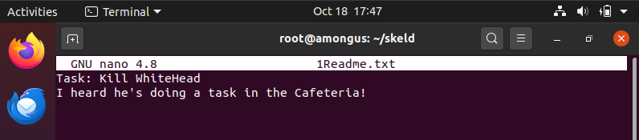

That’s a clue.So we need to start with Cafeteria  
  
**Command : cd Cafeteria.room.txt**  
  
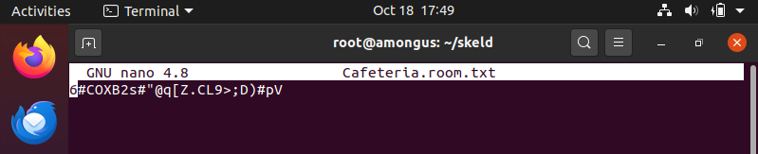

Use online decodes to decode the flag.

Link used - https://gchq.github.io/CyberChef/

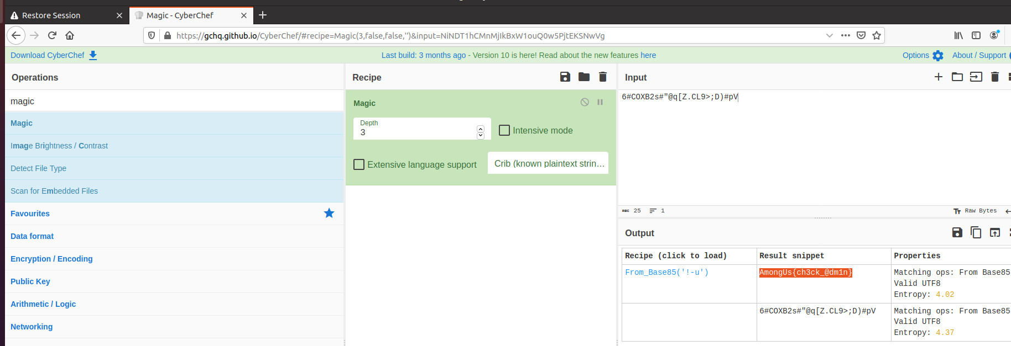

Decode flag - **AmongUs{ch3ck_@dm1n}**

The flag directs to the next location and it is admin.

Now open admin.roon.txt file using the command **nano admin.room.txt**

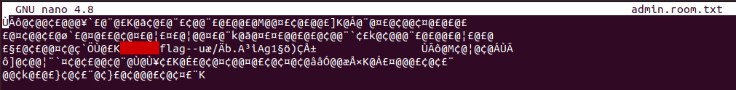

Use the same decoder to decode the file

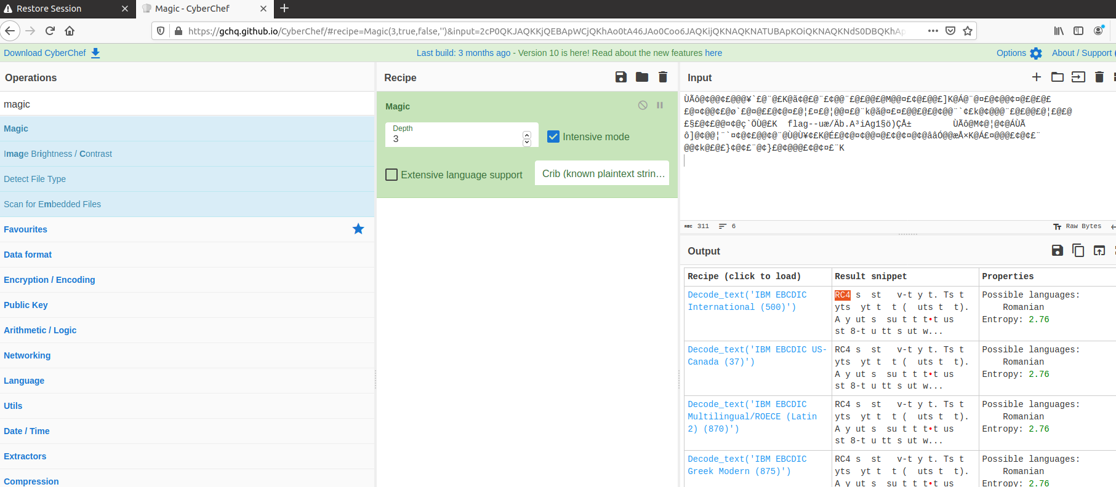

The decoded content gives an hint that the flag is encode using RC4 algorithm.

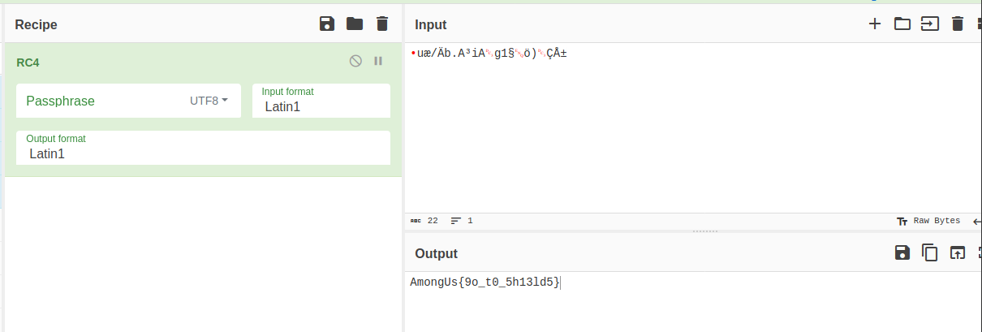

Decrypted flag - **AmongUs{9o_t0_5h13ld5}**

Now it directs the user to the next location shields.

**Command : nano shields.room.txt**

In shields.room.txt



Online decrypter

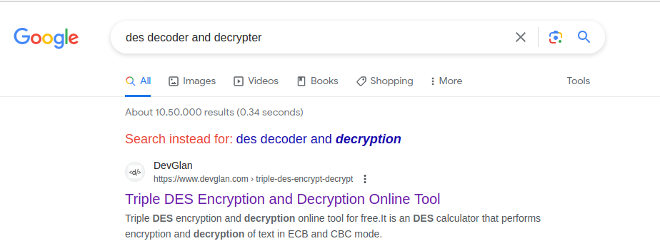

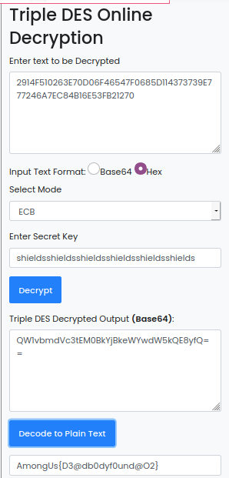

Flag - **AmongUs{D3@db0dyf0und@O2}**

Now it directs the user to the next location O2

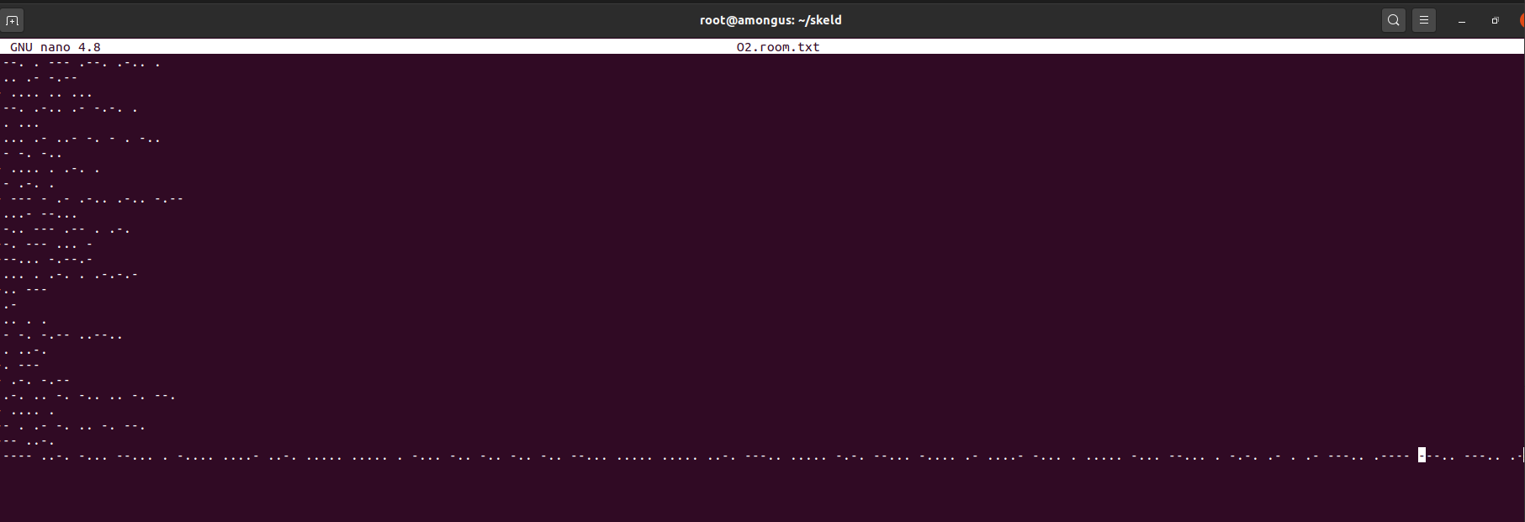

Decrypted content - PEOPLE SAY THIS PLACE IS HAUNTED AND THERE ARE TOTALLY 47 LOWER GOST :) HERE. DO U SEE ANY? IF NO TRY FINDING THE MEANING OF 1FB7E64F55EBDDDD755F85C76A4BE5B7ECAEA8188A842E30C16C9080D889C5A3

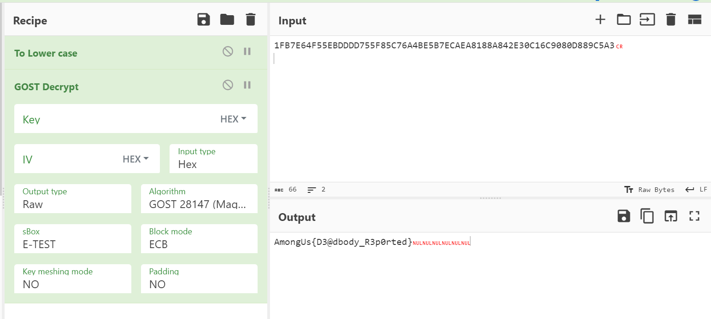

Decrypted flag - **AmongUs{D3@dbody_R3p0rted}**

**Room 2 - Mira-HQ**

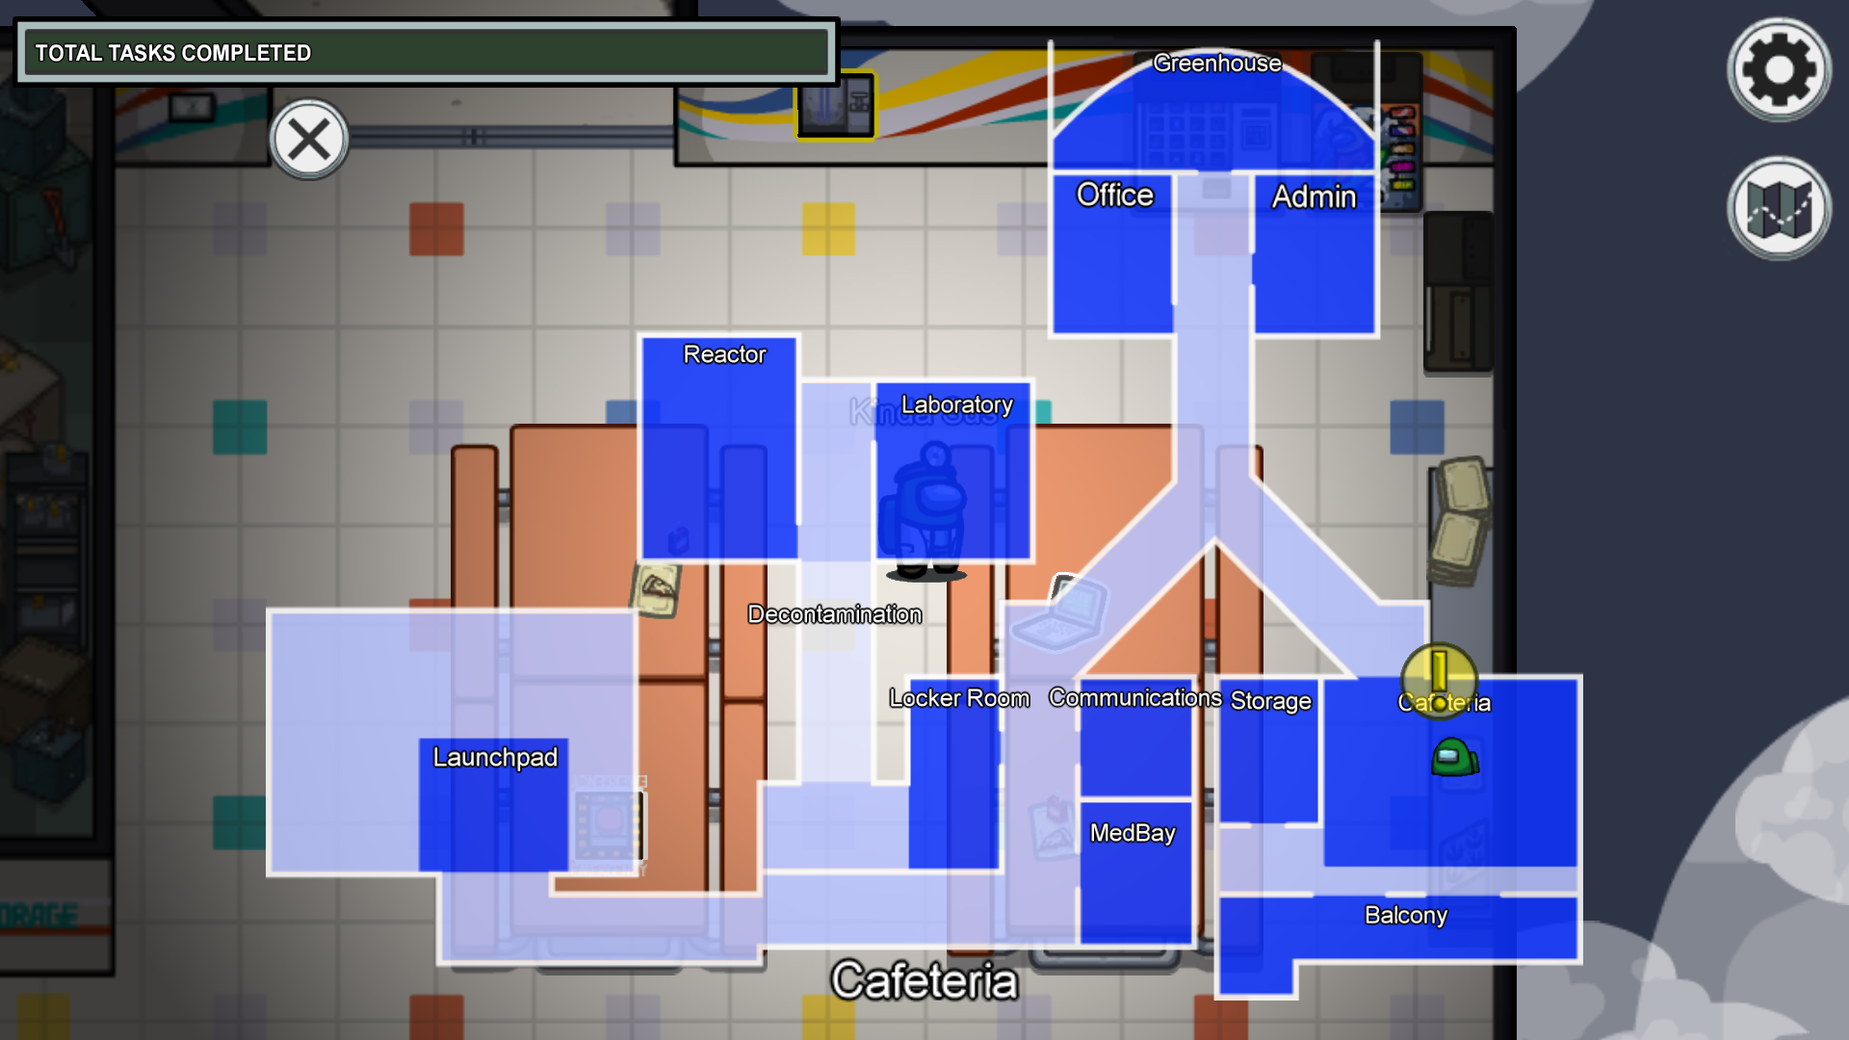

Entering **mira-hq** map, the following files and directories can be found.

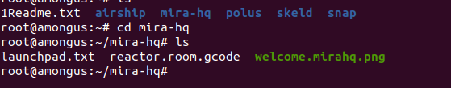

**Welcome.mirahq.png**

The png file can be moved or downloaded from the terminal to the home directory.

The command to move the .png file to home directory is :

mv welcome.mirahq.png /home/Downloads

The image file will be found in the downloads directory.

The image file is

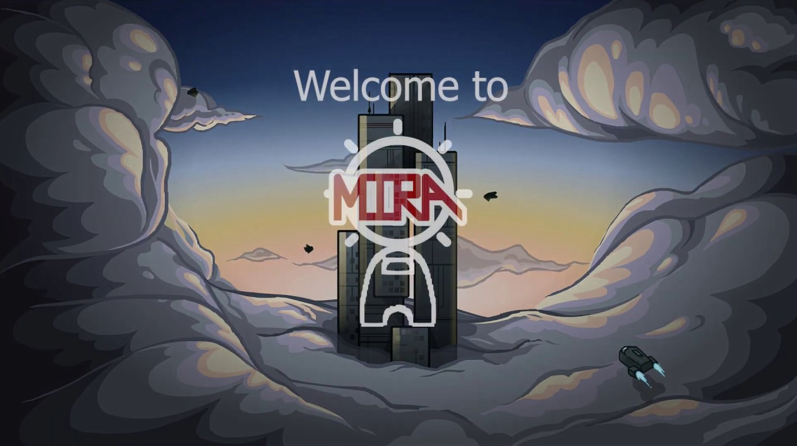

The Flag is hidden in this image. Using online tool the file can be uploaded and the flag can be retrieved.

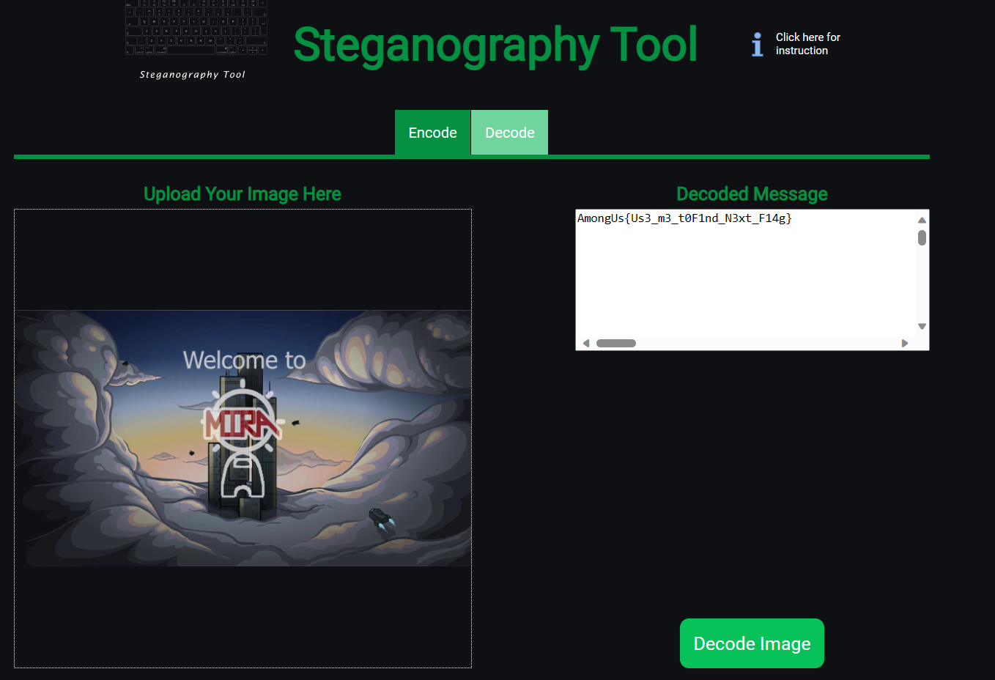

Decrypted flag - **AmongUs{Us3_m3_t0F1nd_N3xt_F14g}**

**reactor.room.gcode**

The file contains gcode which needs to be decoded using online tool.

Using nc viewer the gcode file can be opened. It plots a graph containing flag in it.

Content inside reactor.room.gcode

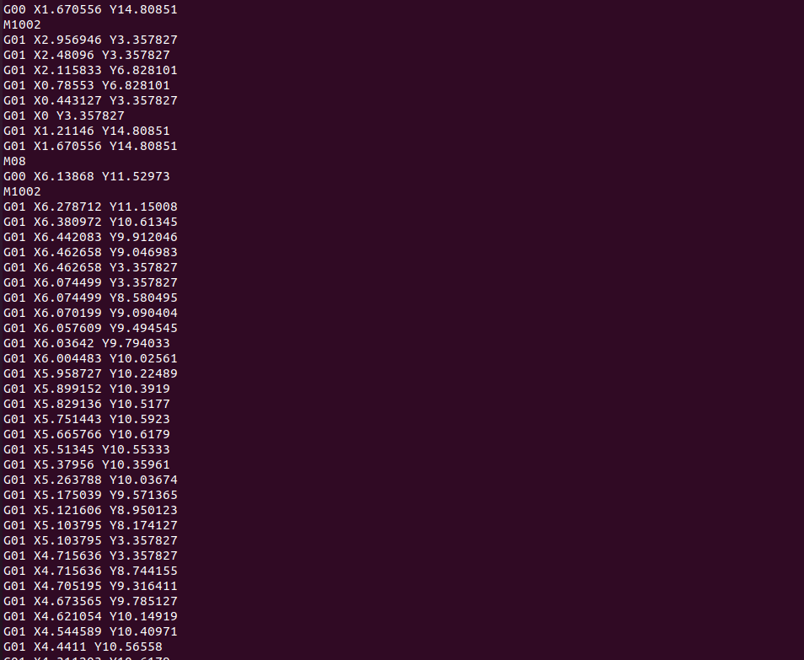

Copying and pasting the content in this file in the tool will give the result.

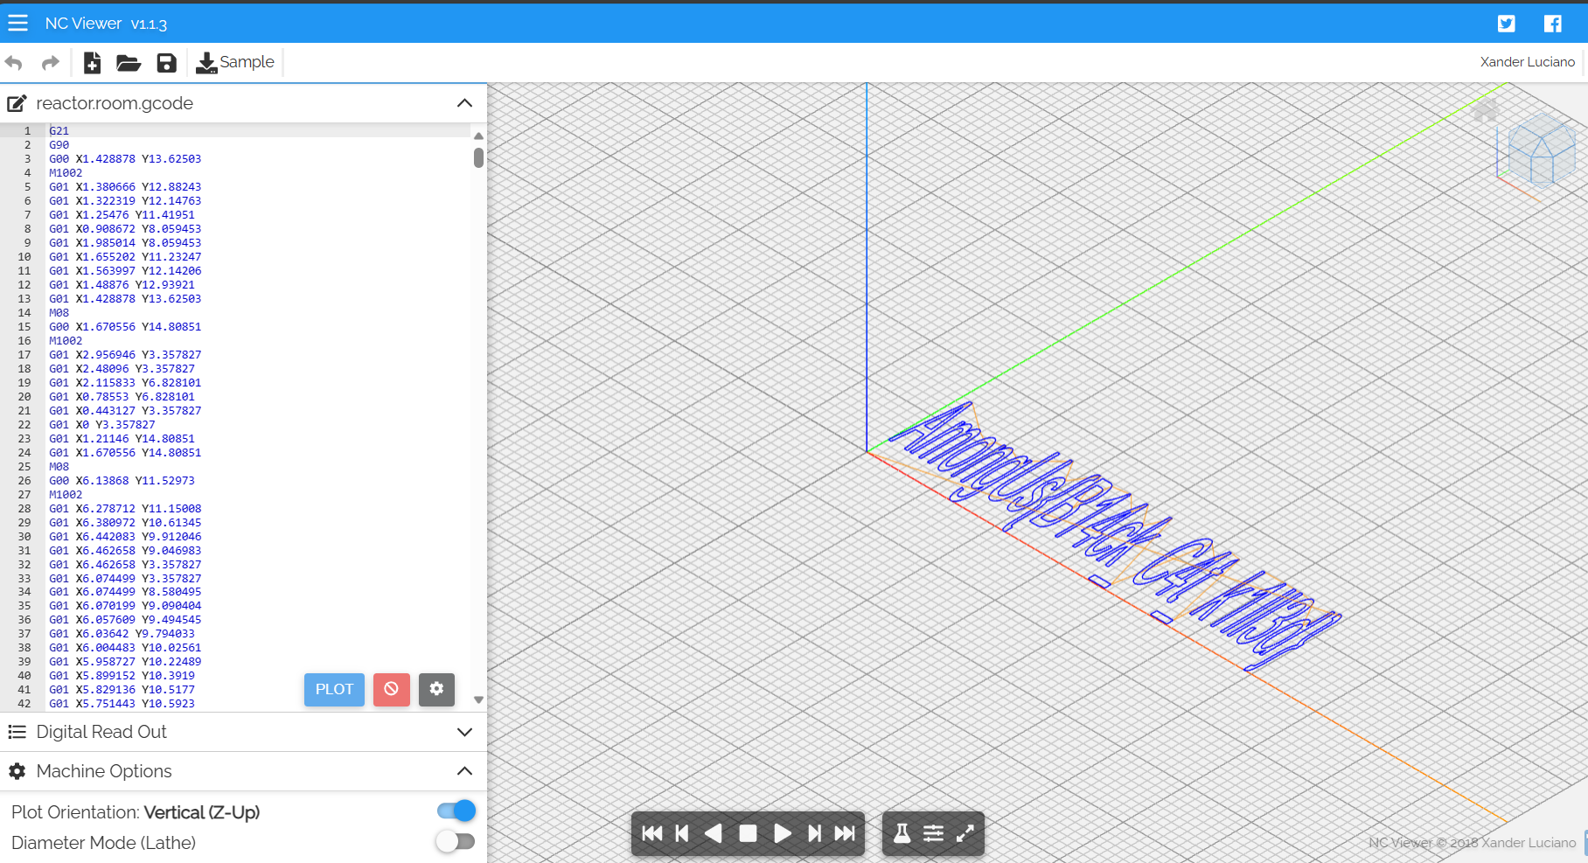

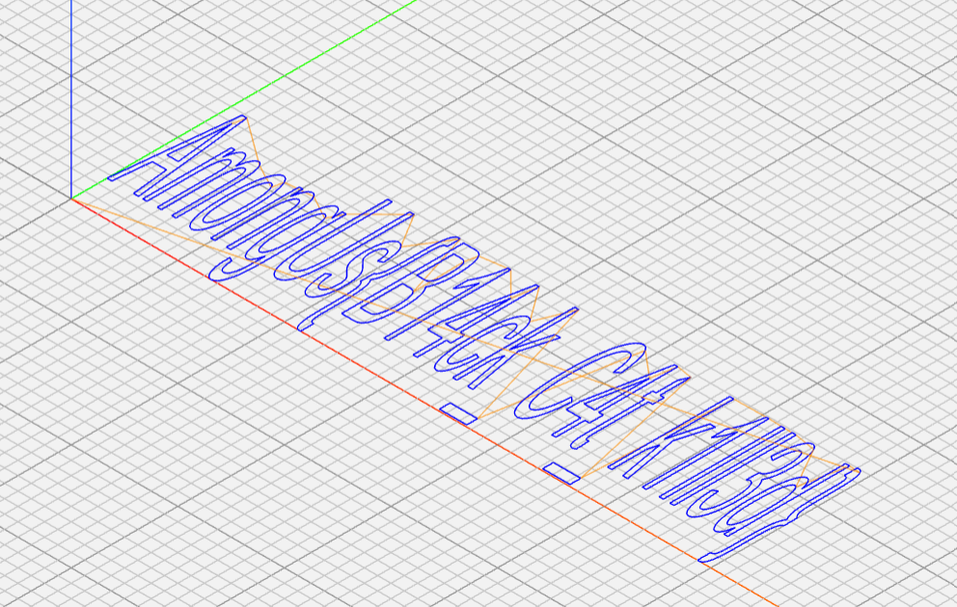

The flag found - **AmongUs{B14ck_c4t_k1ll3d}**

Content in launchpad.txt

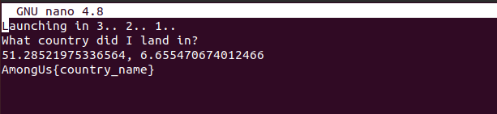

Country name is **Germany**

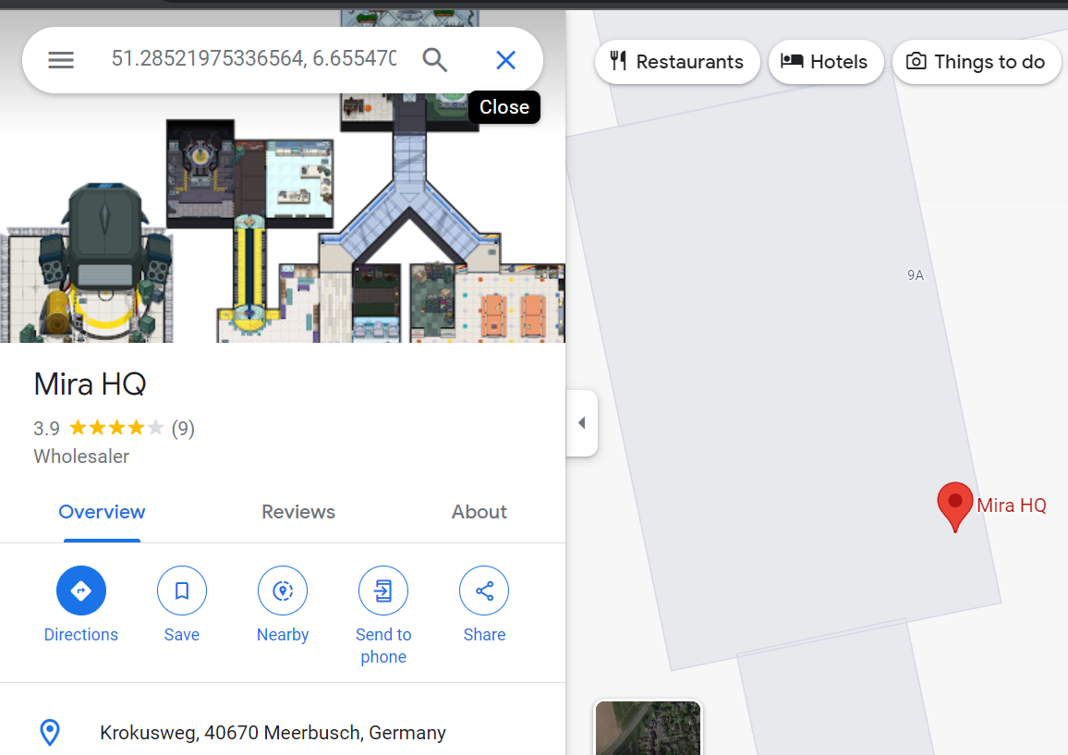

The flag is : **AmongUs{Germany}**

**Room 3 : Airship**

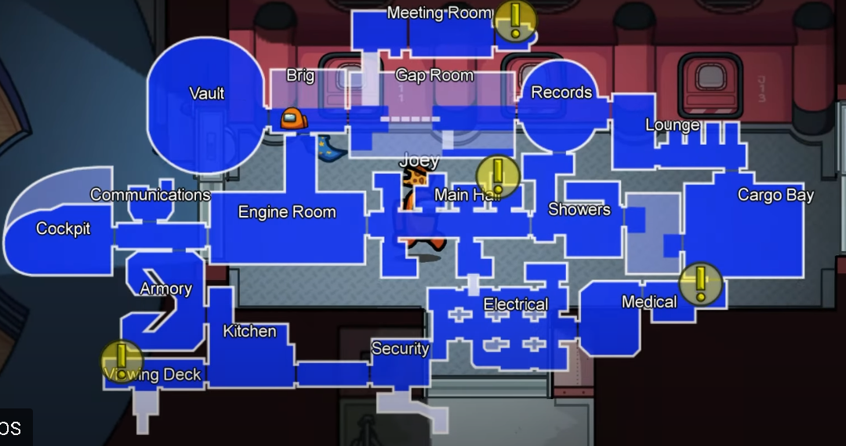

Entering **airship** map, the following files and directories can be found.

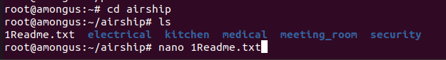

Command : **nano 1Readme.txt**

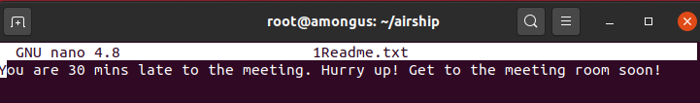

**Meeting_room**

The directory contains the file Important.c which has the flag

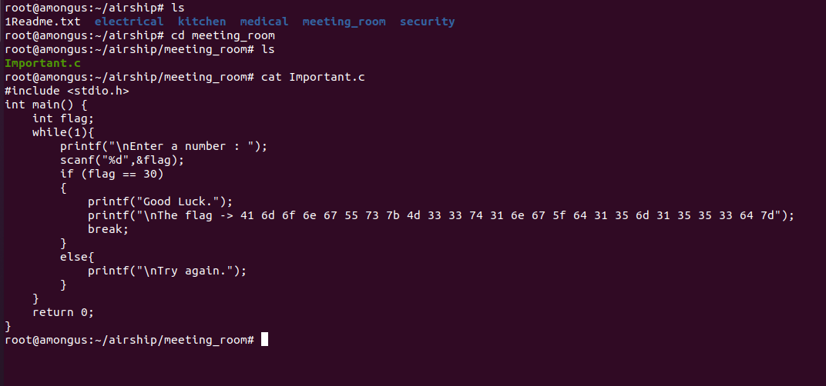

Encrypted flag - 41 6d 6f 6e 67 55 73 7b 4d 33 33 74 31 6e 67 5f 64 31 35 6d 31 35 35 33 64 7d

It’s encoded in charcode.

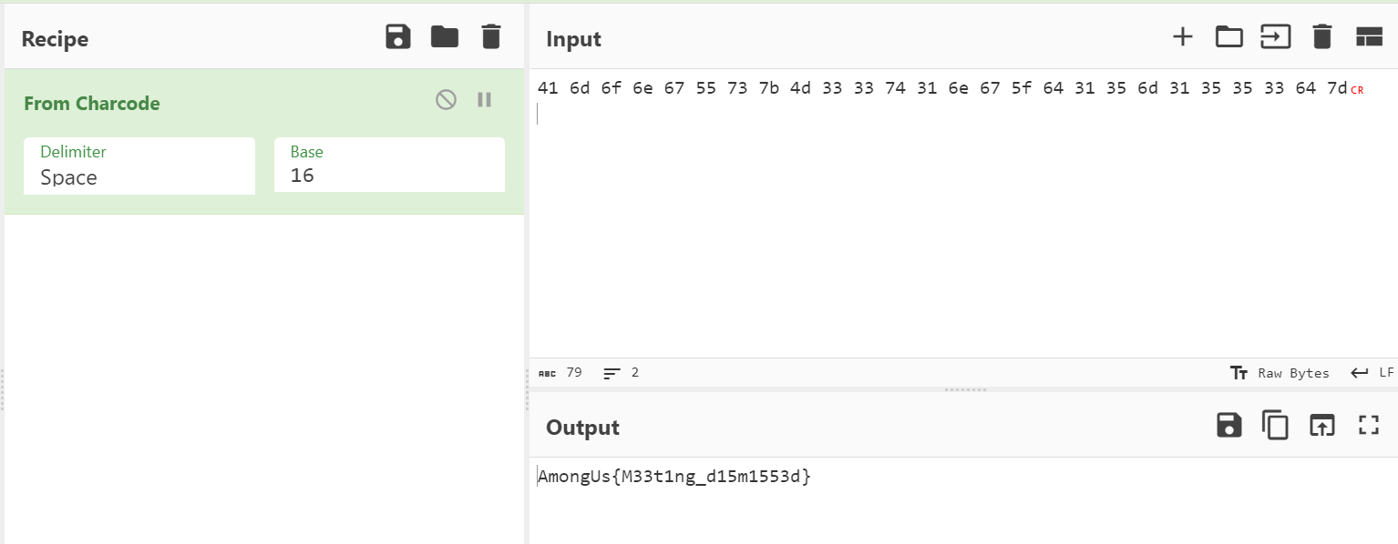

Decrypted Flag - **AmongUs{M33t1ng_d15m1553d}**

**medical**

Files inside medical

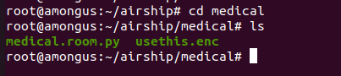

Command : nano usethix.enc

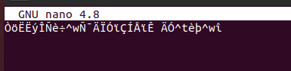

Content inside medical.room.py  
  
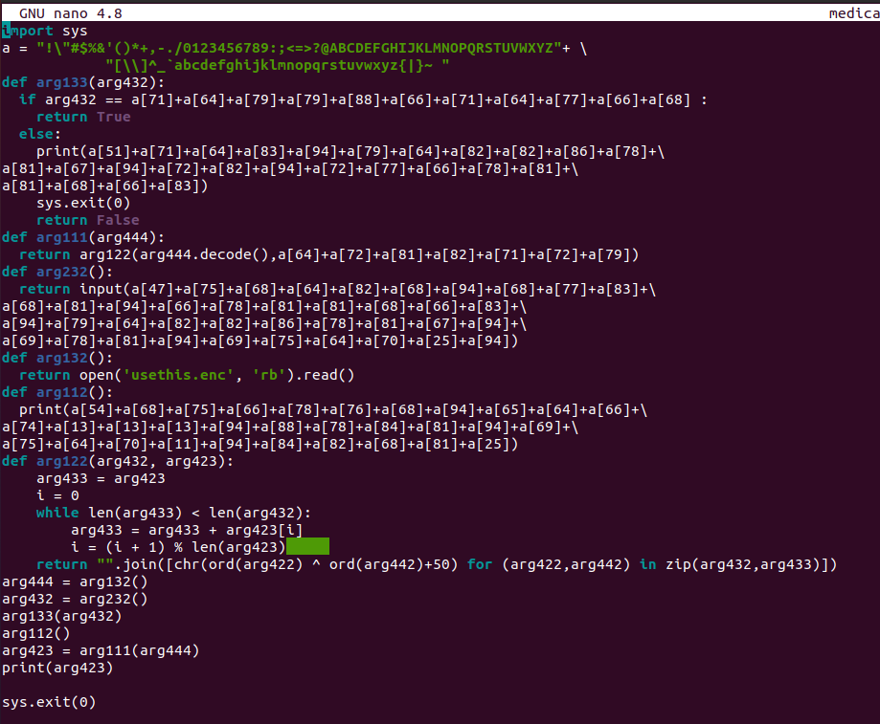

Decode and find the password - happychance

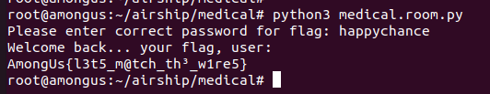

Flag - **AmongUs{l3t5_m@tch_th3_w1re5}**

**Electrical**

Files inside electrical

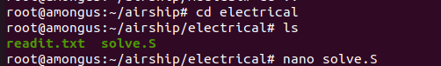

Content inside readit.txt



Content inside solve.S

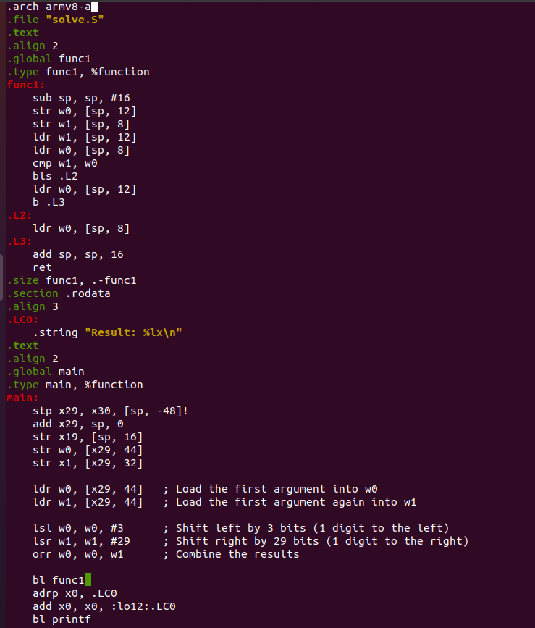

Assembly code that takes the 1st input and does a circular left shift and converts the value to hex.  
The output is : a55e3b19

Flag - **AmongUs{a55e3b19}**

**Security**

Content inside security

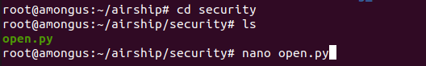

Content inside open.py

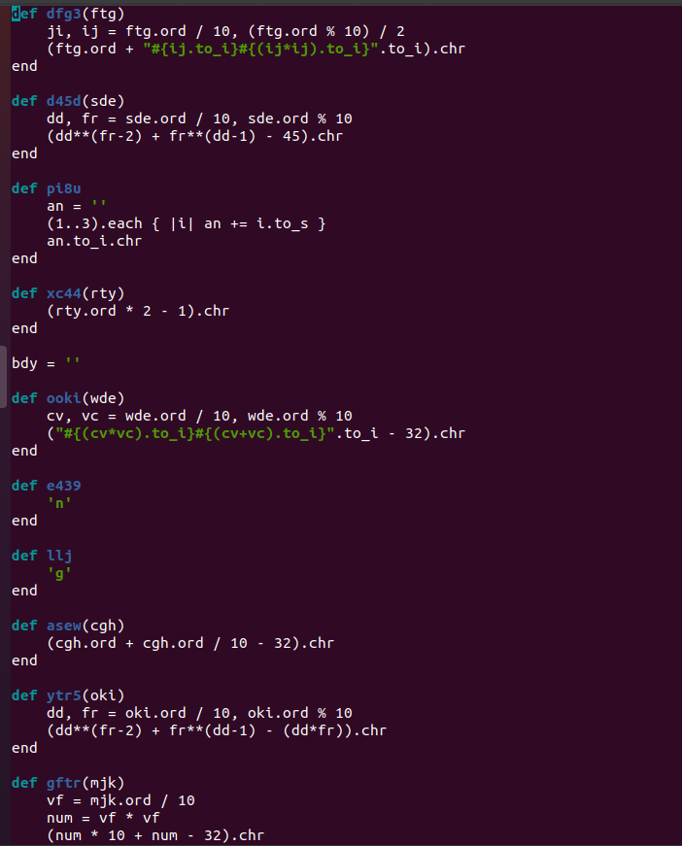

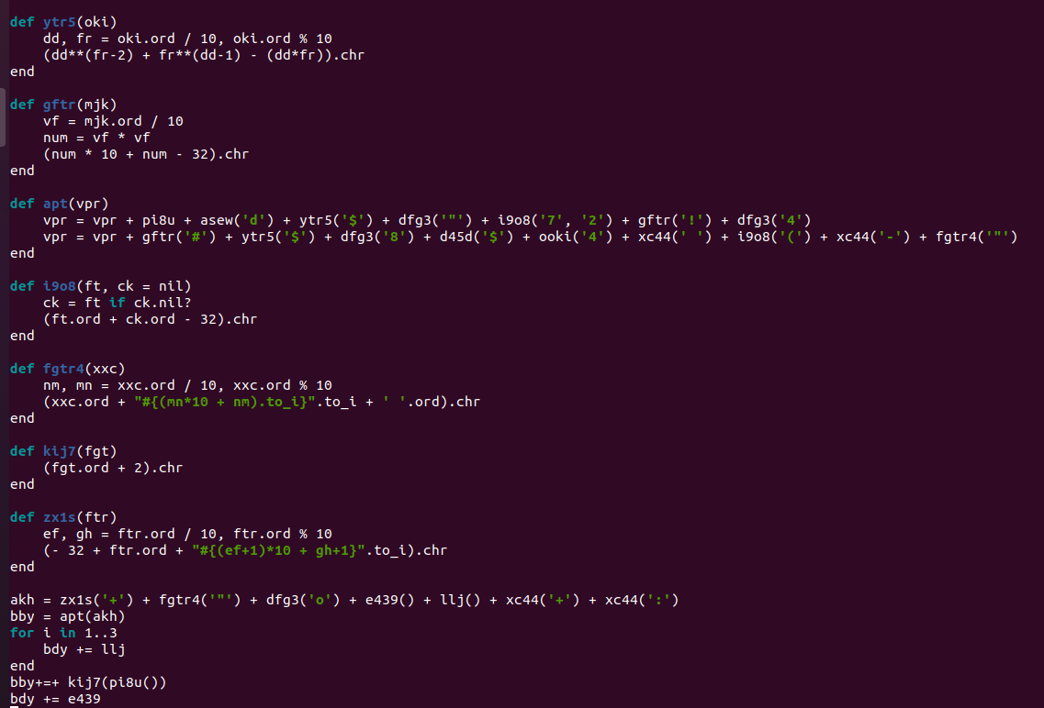

Execute the ruby code to get the flag.

Flag - **AmongUs{Nc:IC?Cc_HK?0Ym}**

**Room 4 - Polus**



Entering **polus**, the following files can be found

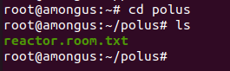

**reactor.room.txt**

it is encrypted using Railfence cipher.

Encrypted flag - AogsKl3_nt3_rw43mnU{1ld@0hrc3mt}

Decrypted flag - **AmongUs{K1ll3d_@n0th3r_cr3wm4t3}**

If we try ls -al, we find another hidden file .storage.txt

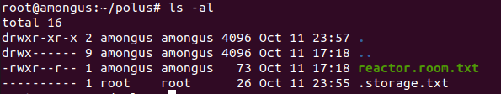

Flag- **AmongUs{jUmp_1n_th3_v3nt}**